**V1 - NFT-ES Mainnet & Translation Requirements**

**Requirement 1:**

**Please Provide us FAQs and their answers.**

**Requirement 2:**

**Polygon Mainnet(Production Ready) Metamask account details:**

As per the discussion from the last version of the requirements, we need a mainnet metamask account Private key which will hold some real matics:

Here is how to make and send the account:

1. Open Metamask:

2. Input your metamask password and Unlock

Make sure you have selected Matic Mainnet from the Networks menu

3. Here you will see your account address and balance:

4. Make sure that you have real matics on your Mainnet Polygon account. (At least 5 Matics for now). In the above picture I have 0 matics in my mainnet account.

5. After you have matics in your account, Send us the private key only for the account. Here is how to export the private key:

Click on 3 Dots on Top right corner:

Click on Account Details:

Export Private Key:

Type your metamask wallet password and click Confirm:

You will get a private key as shown in red:

Copy that private key and provide us so that we may import it in our wallet and use it for the admin side privileges.

**Admin Account Privileges:**

Please be sure that the following privileges and things will be done from this account:

* The gas fee will be deducted from this wallet in case of “Stripe Payments” only.
* All the admin side tasks like(Setting max mint Count, Setting Mint Fees, and Stop/Open Drop site) will be done only if this account is logged into your metamask.  
  Only this account will be used for all the above tasks.
* The admin will be able to withdraw the contract balance. The contract balance is the amount that we have got from the crypto payment method transactions.
  + Admin can withdraw any amount to any address on the same network as shown in the figure:
    - Shown is the current balance of our testnet contract
  + 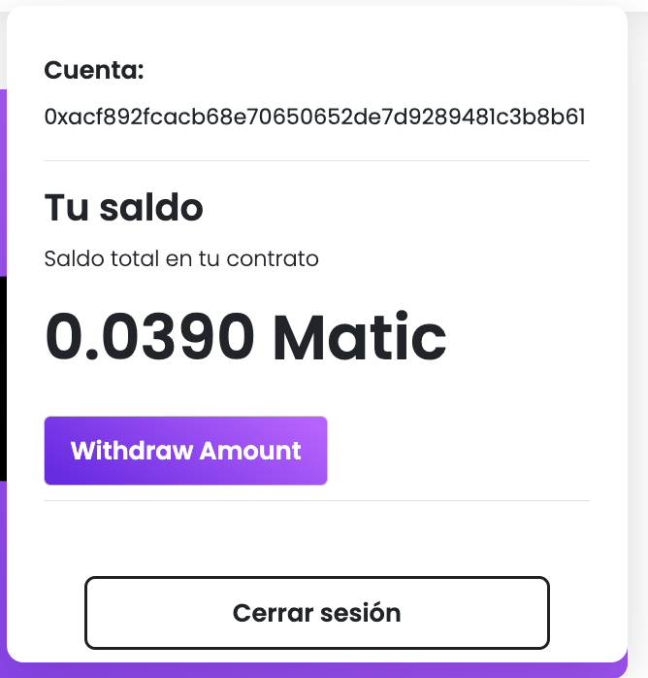
* Here we will need to provide the address where the amount should be sent. [Make sure if an incorrect address is given, the Amount will be lost forever]

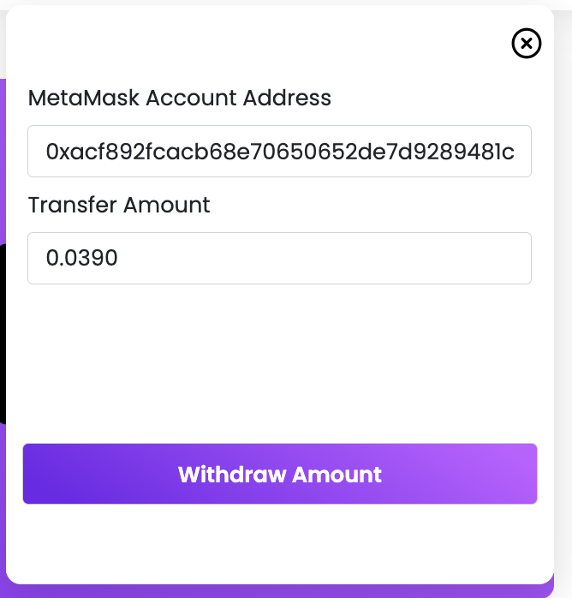

**Requirement 3:**

**More Translations Required:**

|  |  |
| --- | --- |
| **English** | **Spanish Translation** |
| Email address is required. |  |
| Password is required. |  |
| Min 6 latter's are required. |  |
| Reset Password |  |
| Account Login |  |
| Login to your account |  |
| Loading |  |
| Confirm Password |  |
| You must specify a number |  |
| Connected |  |
| Online payment failure from stripe. |  |
| We received your purchase request  we will be in touch shortly!You cannot process account without metamask connection.Found metamask connection error. |  |
| Install metamask extension before you going to process. |  |
| Data saved successfully. |  |
| You need minimum 5 MATIC |  |
| Mint Fee is not yet set so you can not process this transaction. |  |
| Server error please try after some time. |  |
| Type |  |
| Verify Links |  |
| Link |  |
| Pay With Card |  |
| Connected |  |
| MetaMask Balance |  |
| You have insufficient balance to continue this transaction. |  |
| [Continue to perform this transaction. After successful transaction you will receive an email on email@gmai.com](mailto:email@gmai.com) |  |
| Install metaMask extension |  |
| This address has not any access to mint before time ends. |  |
| Drop site is down You can not make any transaction. |  |
| Email address is required.Error while creating nft. |  |
| Admin login successfully. |  |
| Wrong email. |  |
| admin settings |  |
| No Settings Found. |  |
| record save successfully. |  |
| record is not formatted. |  |
| Password updated successfully.Redirecting to dashboard |  |
| Opt verification failed. |  |
| No account found related to this email. |  |
| Opt verification successfully. |  |
| Opt verification failed. |  |
| No account found related to this email. |  |
| Reset password email sent successfully. |  |
| Email sending error Please try after some time. |  |
| No account found related to this email. |  |
| Otp creating error. |  |
| Settings updated successfully. |  |
| Server error while updating admin settings. |  |
| Amount can not be equal to 0. |  |
| Error while creating nft. |  |
| Error while uploading nft. |  |
| Error while uploading file to s3. |  |
| 3 items minted successfully. |  |
| Some validation errors. |  |
| stripe payment error. |  |
| Stripe payment link creating error. |  |
| Total Nft-re are required or not yet amount is set. |  |
| email send successfully. |  |
| No account details found. |  |